# Validate

## Basic workflow

1. Store rules using validate function

1. Check rules with confront function



1. Summary results

|  |
| --- |
|  |
|  |

## Filter row problems

If we applied a rule by groups, we just need to get the unique value of those problems.

## Ruling tips

1. Use all and any (or **all_complete**)

1. Adding rules

1. Saving variables

1. Adding variables from global env

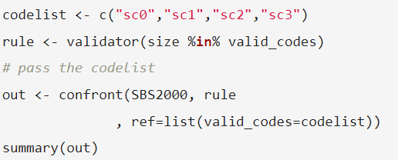

1. Changing inequation and equation tolerances

## Validate functions

### By row functions

**If**

**field_length:** nchar(as.character(size)) >= 2

**in_range:**

**%vin%:**

**is_unique:**

### By group functions

**do_by:**

|  |  |
| --- | --- |
| **exists_one** | **exists_any** |
| Checks is_unique for a value in a group. | Checks if there is one value por group. |

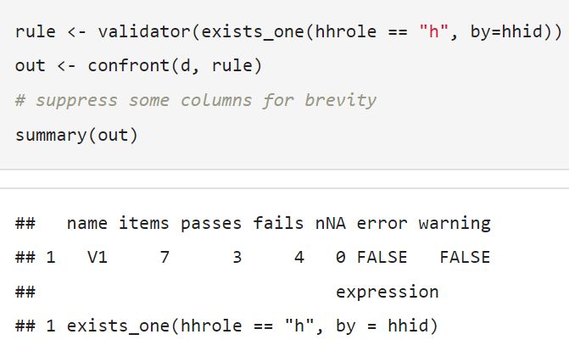

|  |  |  |
| --- | --- | --- |
| **contains_exactly** | **contains_at_least** | **does_not_contain** |
| Checks if a data.frame has all combinations listed in the validate data.frame. | Checks if a data.frame is not missing any combination given in the validate data.frame. | Checks if a data.frame don’t have any combination given in the validate data.frame. |

**rx:** extends to the validate data.frame to be a list of regular expressions.

**is_linear_sequence:** Checks if there is a constant distance between each two elements.

|  |  |
| --- | --- |
|  |  |

**in_linear_sequence:** Checks the linear sequence by row.

**hierarchy:** the volumes for subclasses "01.11" and "01.12" add up to "01.1" (30+40=70).

